**FUNCTIONS OVERVIEW**

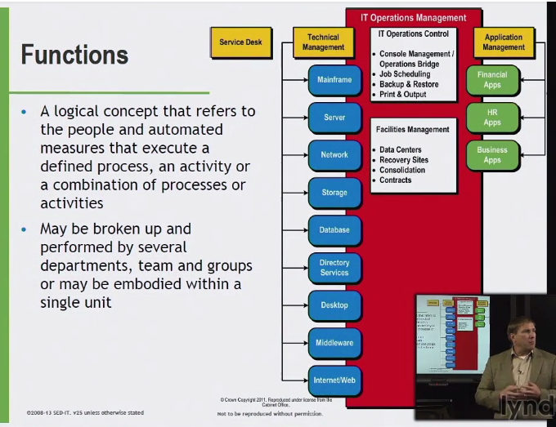

**SERVICE DESK ORGANIZATIONAL**

**LOCAL SERVICE DESK –** CO-LOCATED OR CLOSE TO USER POPULATION THAT IT SUPPORTS

**CENTRAL SERVICE DESK –** HEIARCHY – MAY SUPPORT LOCAL OFFICES LOCAL DESKS – BUT HAVE CENTRAL SERVICE DESK

* LEVERAGE RESOURCE AT OTHER SERVICE DESKS

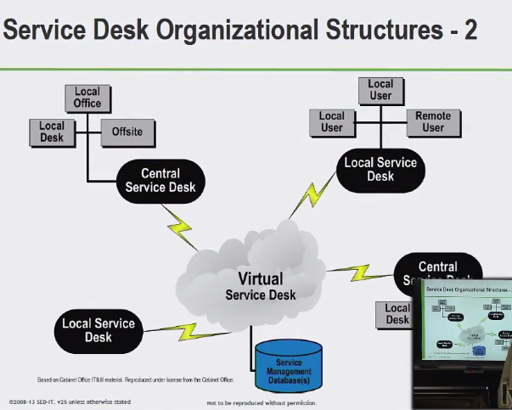

**VIRUTAL SERVICE DESK**

* LINK MULTIPLE LOCAL/CENTRAL SERVICE DESKS
* USE SET OF CORP. TOOLS/TECH
* COMMON SET OF TOOLS/INFO FROM CORPORATE LEVEL

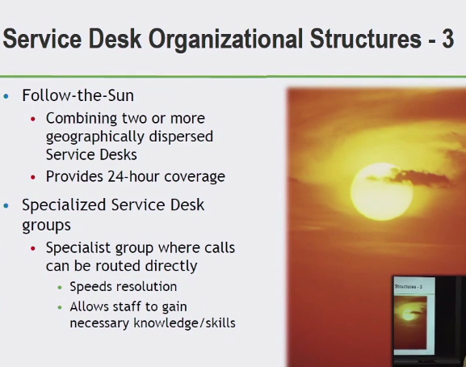

LOCAL

CENTRAL

FOLLOW-THE-SUN

VIRTUAL

SPECIALIZED

**SERVICE DESK AND OBJECTIVES**

* SINGLE POINT OF CONTACT BETWEEN USERS AND IT SERVICE PROVIDERS
* FUNNEL CALLS MANAGE REQUESTS/INCIDENTS IN ORGANIZED FASHION EFFICIENT MANNER

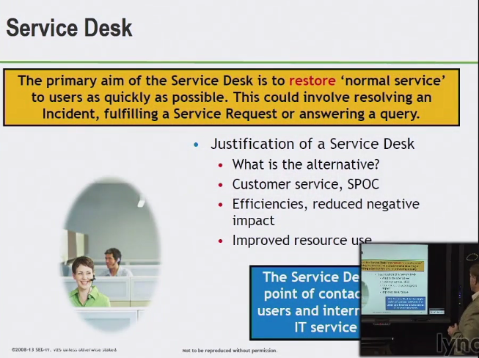

NORMAL SERVICE – SERVICE LEVEL EXPECTATION

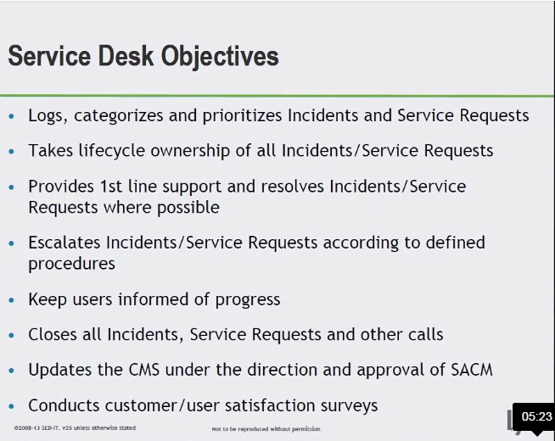

**TECHNICAL MANAGEMENT**

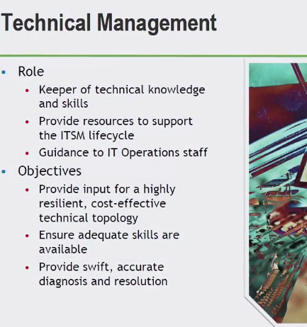

* KNOW/UNDERSTAND WHATS TAKING PLACE IN THE INDUSTRY
* HOW WE CAN BETTER OUR TECHNICAL INFRASTRUCTURE LEVERAGING THE PROCESSES WE HAVE
* INCIDENT/PROBLEM TICKETS
* ESCALATED INCIDENTS
* WORKING WITH PROBLEM TICKETS ASSOCIATED WITH TECHNOLOGY

**ITSM (INFO TECH SERVICE MAN.)**

**IT OPERATIONS MANAGEMENT**

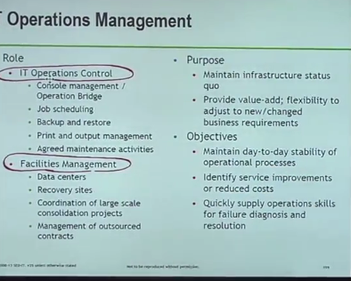

**IT OPERATIONS CONTROL**

* ACTIVE MONITORING/EVENT MAN.
* TYPICAL JOBS BACKUP AND RESTORE MASTER SCHEDULING OF THOSE JOBS
* PRINT AND OUTPUT – PHYSICAL&ELECTRONIC ACTIVITIES

**FACILITIES MANAGEMENT**

* PHYSICAL DATA CENTERS

**APPLICATION MANAGEMENT**

* MANAGING APPS THROUGHOUT THEIR LIFE-CYCLE AS A FUNCTON

**APPLICATION**

* SUPPORT ONE OR MORE SERVICES
* SHARED SERVICE

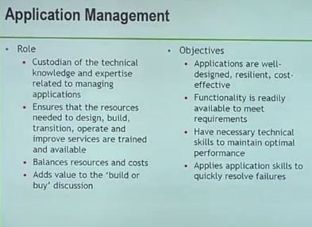

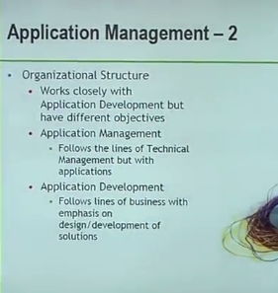

APPLICATION MAN. VS. APPLICATION DEV.

**APPLICATION DEV.**

* CONSTRUCTION

**APPLICATION MAN.**

* ON-GOING SUPPORT

**SUMMARY: FUNCTION**

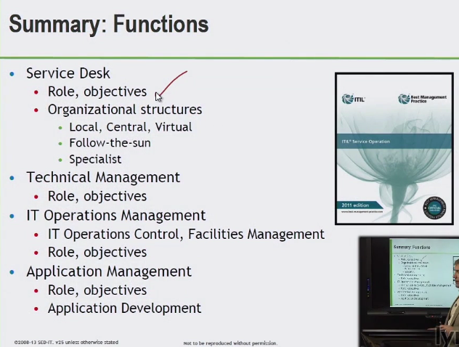

**SERVICE DESK**

* ROLE: PROVIDE SINGLE POINT OF CONTACT: SERVICE PROVIDER AND USER

FOR OPERATIONAL TYPES OF ISSUES – INCIDENT REQUESTS

**ORGANIZATIONAL STRUCTURES**

1. LOCAL
2. CENTRAL
3. VIRTUAL
4. FOLLOW-THE-SUN
5. SPECIALIST

**TECHNICAL MANAGEMENT**

* TECHNICAL KNOWLEDGE
* RISLIENT TECH INFRASTRUCTURE TO SUPPORT SERVICES
* EXPERTS THAT KNOW THAT SUPPORT LIFE-CYCLE PHASES

**IT OPERATIONS MANAGEMENT**

* **CONTROL**
  + BRIDGE/CONTROL TOWER
  + MONITORING
* **FACILITIES**
  + PHYSICAL DATA CENTERS

**APPLICATION MANAGEMENT**

* RESOURCE PLANNING
* ON-GOING OPERATIONAL SUPPORT

**APPLICATION DEVELOPMENT**

* LOOKING AT THE BUILD/CONSTRUCT